Practical 1

Name : Soumya Dixit

PRN : 23070521151

Semester : 4th

Section : B

Batch : B2

Task 2 : Design and ER Diagram and Relational Model for the following problem statement ( Smart Healthcare Management System )

|  |  | Patient |  |  |  |
| --- | --- | --- | --- | --- | --- |
| Patient ID | Name | Age | Gender | Contact information | Address |
| 22300768 | Disha | 23 | female | 9999999990 | jaipur |
| .. | .. | .. | .. | .. | .. |
| .. | .. | .. | .. | .. | .. |

| Treats |  |
| --- | --- |
| Doctor ID | Patient ID |
| 11112222 | 22300768 |
| .. | .. |
| .. | .. |

|  |  | Doctor |  |  |  |
| --- | --- | --- | --- | --- | --- |
| Doctor ID | Name | Specialty | Qualification | Work Schedule | Contact Information |
| 11112222 | Prakash | **Dermatologist** | MD in Dermatology | 8 AM – 8 PM | 9999988880 |
|  |  |  |  |  |  |
|  |  |  |  |  |  |

|  |  | Medication |  |  |
| --- | --- | --- | --- | --- |
| Medication ID | Manufacture | Name | Dosage | Expiry Date |
| 0000022 | xxx | aaa | 2 or 3 times a day | 11-Mar-20XX |
| .. | .. | .. | .. | .. |
| .. | .. | .. | .. | .. |

|  |  | Appointment |  |  |
| --- | --- | --- | --- | --- |
| Appointment ID | date | time | Reason to visit | status |
| 212121 | 10 – Jan – 22XX | 3 PM | Acne | revisit |
| .. | .. | .. | .. | .. |
| .. | .. | .. | .. | .. |

|  | Room |  |
| --- | --- | --- |
| Room ID | Room type | Availability Status |
| 000022 | single | Available |
| .. | .. | .. |
| .. | .. | .. |

|  |  | Billing |  |  |
| --- | --- | --- | --- | --- |
| Patient ID | Bill ID | Appointment ID | Total amount | Payment Status |
| 22300768 | Aa00023 | 212121 | 2,300 | URL |
| .. | .. | .. | .. | .. |
| .. | .. | .. | .. | .. |

|  |  | Staff |  |
| --- | --- | --- | --- |
| Staff ID | Name | Role | Assigned Department |
| 5555 | qqq | Nurse | Derma |
| .. | .. | .. | .. |
| .. | .. | .. | .. |

|  |  | Equipment |  |  |
| --- | --- | --- | --- | --- |
| Equipment ID | Name | Type | Assigned Department | Maintenance Schedule |
| 4444 | ee | rr | Derma | Every Monday at 2 PM |
| .. | .. | .. | .. | .. |
| .. | .. | .. | .. | .. |

|  | Manages |
| --- | --- |
| Staff ID | Equipment ID |
| 5555 | 4444 |
| .. | .. |
| .. | .. |

|  | Handle |
| --- | --- |
| Staff ID | Billing ID |
| 5555 | Aa00023 |
| .. | .. |
| .. | .. |

|  | Allotted |
| --- | --- |
| Room ID | Patient ID |
| 000022 | 22300768 |
| .. | .. |
| .. | .. |

|  | Has |
| --- | --- |
| Patient ID | Appointment ID |
| 22300768 | 4444 |
| .. | .. |
| .. | .. |

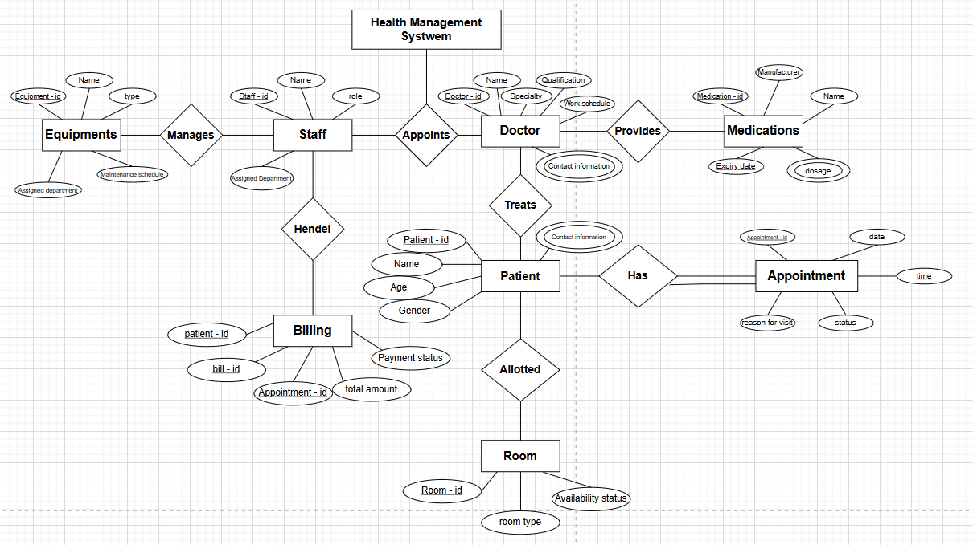



Task 3 : Draw EER Diagram and Relational Model for Bank Management System

|  |  | Customer |  |  |
| --- | --- | --- | --- | --- |
| Customer ID | Name | Address | Email | Phone |
| 222 | ss | xyz | ab@gmail | 3322332233 |
| .. | .. | .. | .. | .. |
| .. | .. | .. | .. | .. |

|  |  | Account |  |  | Is a |
| --- | --- | --- | --- | --- | --- |
| Interest rate | Balance | Account ID | Type | Checking  (Over draft limit) | Saving ( minimum balance ) |
| 7 % | 67,000 | Aa223 | saving | .. | 35,000 |
| .. | .. | .. | .. | .. | .. |
| .. | .. | .. | .. | .. | .. |

|  |  | Transaction |  |  |  | Is a |  |
| --- | --- | --- | --- | --- | --- | --- | --- |
| Transaction ID | Date | Account |  | Amount | Transfer | Withdrawal | Deposit |
|  |  | Source | Destination |  |  |  |  |
| 223333 | 23–Mar– 20x | aa | bb | 50,000 | 2,000 | .. | .. |
| .. | .. | .. | .. | .. | .. | .. | .. |

|  | Employee |  |  | Is a |
| --- | --- | --- | --- | --- |
| Employee ID | Name | Assigned branch | Manager (department) | Teller |
| Ww333 | nn | pp | pp | .. |
| .. | .. | .. | .. | .. |
| .. | .. | .. | .. | .. |

|  | Branch |  |
| --- | --- | --- |
| Branch ID | Location | Phone number |
| pp | ii | 2121212121 |
| .. | .. | .. |
| .. | .. | .. |

|  | Loan Management |  |
| --- | --- | --- |
| Instalment ID | Instalment date | Instalment amount |
| 33aa4 | 22-Feb-2000 | 5,00,000 |
| .. | .. | .. |
| .. | .. | .. |

|  |  |  | Loan |  |  |
| --- | --- | --- | --- | --- | --- |
| Loan ID | Interest rate | Loan amount | Start date | End date | Status |
| 8888 | 8% | 8,00,000 | 8-Aug-2020 | 7-Aug-2022 | Unpaid |
| .. | .. | .. | .. | .. | .. |
| .. | .. | .. | .. | .. | .. |

|  | Perform |
| --- | --- |
| Account ID | Transaction ID |
| Aa223 | 223333 |
| .. | .. |

|  | Involves |
| --- | --- |
| Customer ID m | Transaction ID 1 |
| 222 | 223333 |
| .. | .. |

|  | Owns |
| --- | --- |
| Customer ID n | Account ID 1 |
| 222 | Aa223 |
| .. | .. |

|  | Associated |
| --- | --- |
| Customer ID | Branch ID |
| 222 | pp |
| .. | .. |

|  | Managed by |
| --- | --- |
| Branch ID | Employee ID |
| pp | Ww333 |
| .. | .. |

|  | Applies |
| --- | --- |
| Customer ID | Loan ID |
| 222 | 8888 |
| .. | .. |

